Minnesota Aviation Day

at the Capitol

Wednesday 25 April 2018
Sponsored by MATA, MBAA, & MCOA
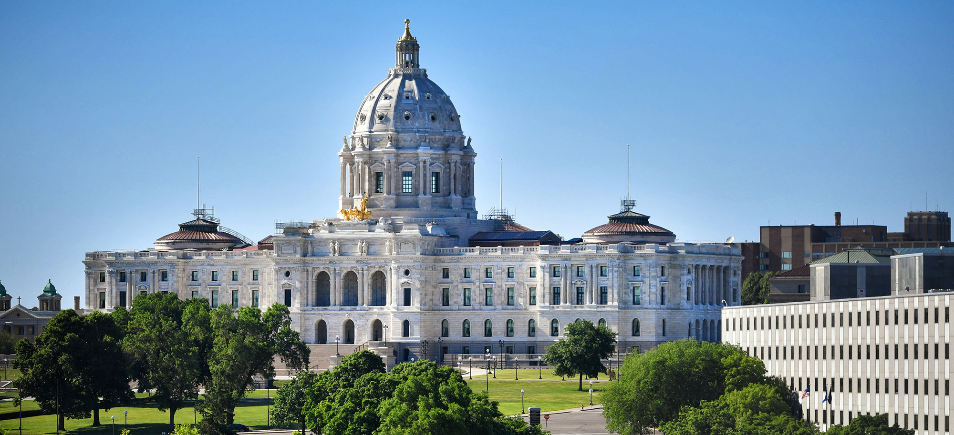
7th Annual Event Schedule
1000 Kick-Off at St. Paul Airport Terminal
1030 – 1130 Legislative Issues Update
1130 – 1330 Luncheon with Legislators Cost $25.00
1400 – 1600 Group Meetings with Legislators
1630 – 1800 Social with Legislators
Location: Saint Paul Airport Terminal
644 Bayfield Street, Saint Paul, MN 55107
Contact: Tim Cossalter 651-269-1221
timcossalter@outlook.com
Register on Line & schedule legislator meetings at:
https://mbaa-mn.org/
Fixed Base Operators – Airport Managers – Airport Commissioners – Mayors
City Council Members – Business Aircraft Owners & Operators
Corporate Flight Departments – Aircraft Technicians
Aviation Support Service Professionals
Pilots & Aviation Enthusiasts

